This QRG outlines the steps to create calendars and submit calendars for review/approval, using the Summer Pay Tool. Faculty members can perform these actions for themselves and their subordinates.

Access the Summer Pay Tool
Visit OneCampus and select SEEMLESS. | https://one.purdue.edu/
Login using Purdue Career Account Login and Password

Summer Pay Homepage
Once logged in, the Summer Pay Dashboard is displayed.  Click Refresh My Info. | 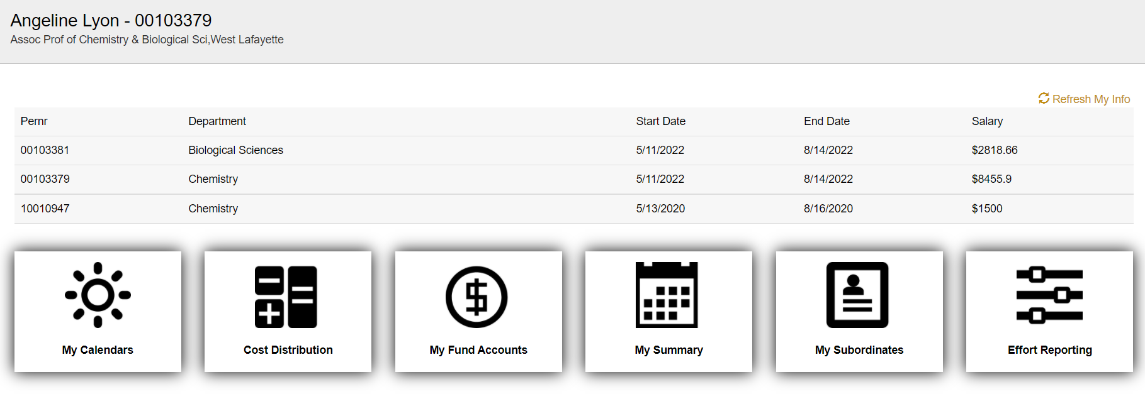
If there are multiple PERNRs, click on the PERNR line that you want to submit the calendar on. Notice the PERNR # will change in the upper left-hand corner.

Click My Calendars.

My Calendars
The Calendars are displayed.
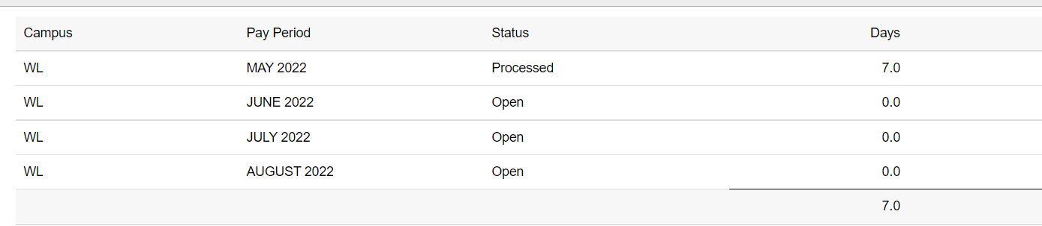

Calendars
Click to select a calendar.  Calendars will be listed by Month or Pay Period.  Monthly calendars will be titled Month 20XX.  Pay Period calendars will be titled with WEYYYYMMDD 20XX; WE = Week Ending. | 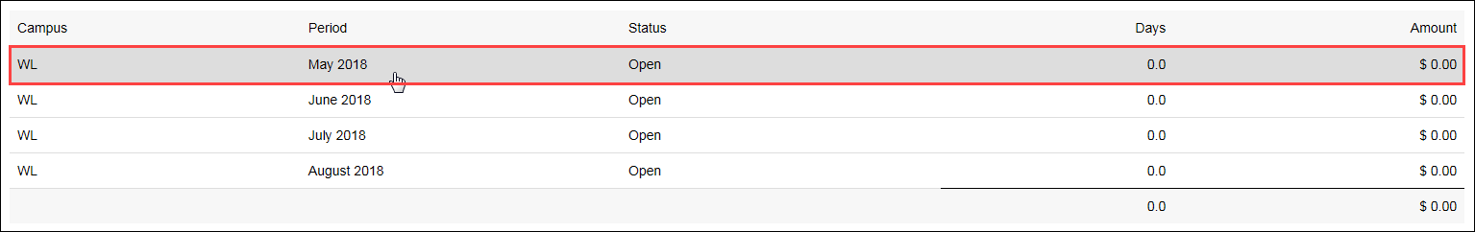  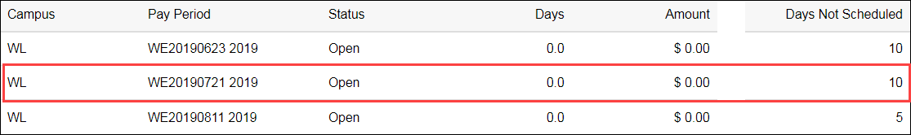
An overview of the calendar is displayed. | 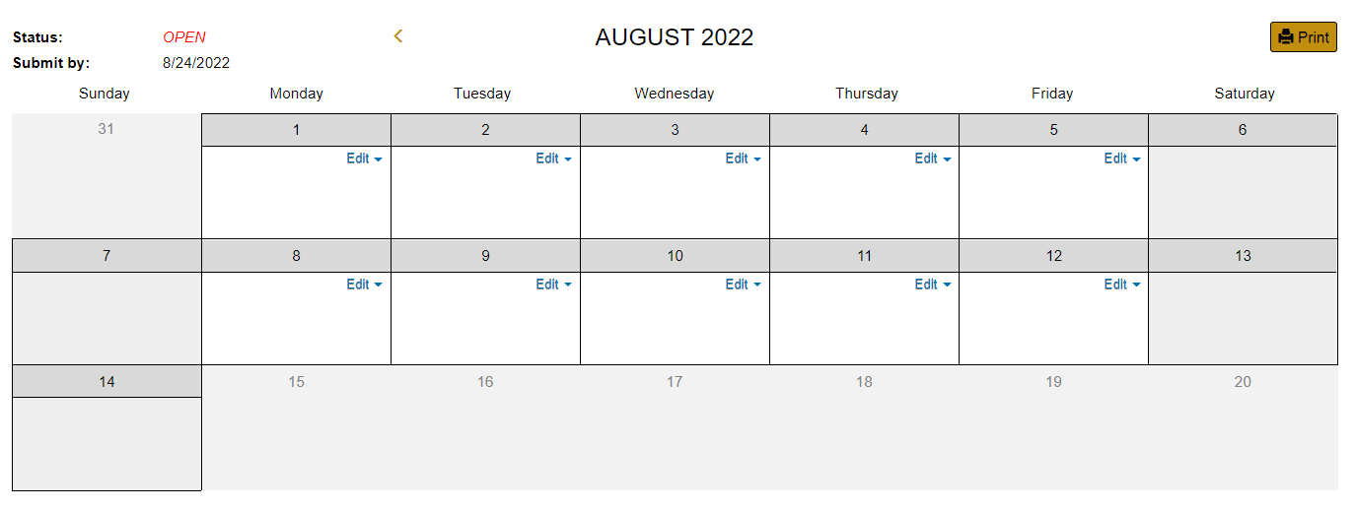
Definitions for calendar entries are displayed on the left side of the page.  T, R, or O (Teaching, Research & Other) should be selected based on the type of duties being performed and not based off of the funding source. | 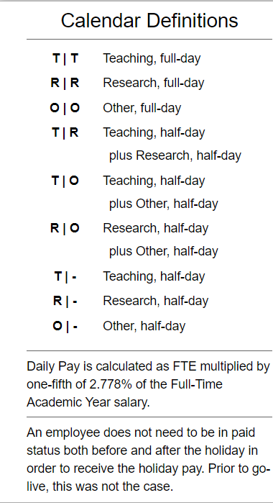
An editable calendar displaying all workdays for the selected month is displayed.
To enter the work category, click the Edit button.  From the drop-down, and using the definitions, select the abbreviation for the type of work performed for the selected day. | 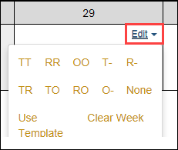
To apply a template, click Use Template.  Select a saved template and apply to the Week or Period.  -or-  Select a Work Type and apply it to the Period. | 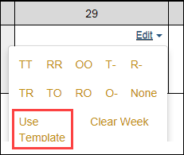  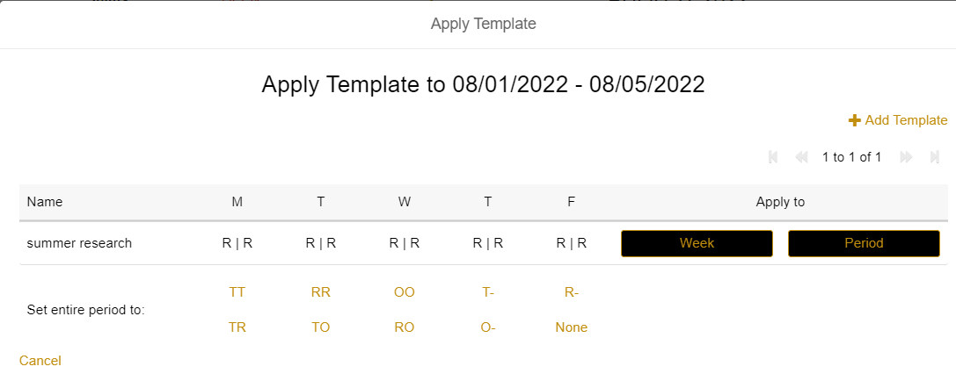  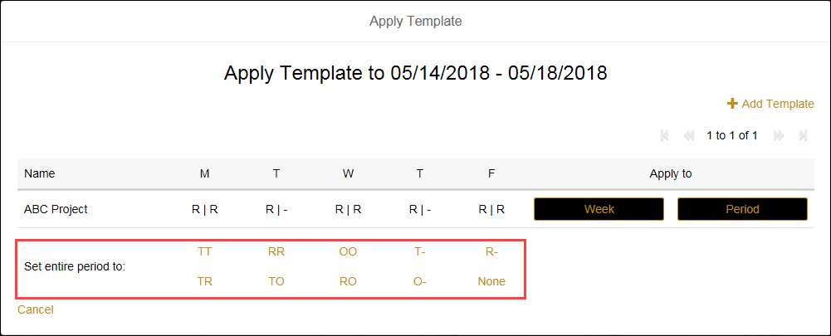
Repeat for each day or week the faculty will receive Summer Pay  When finished, the Pay Period Activity summary is displayed below the calendar  Select Send to Business Review  Click Yes, Submit Calendar or No, Cancel Submission if you need to make updates | 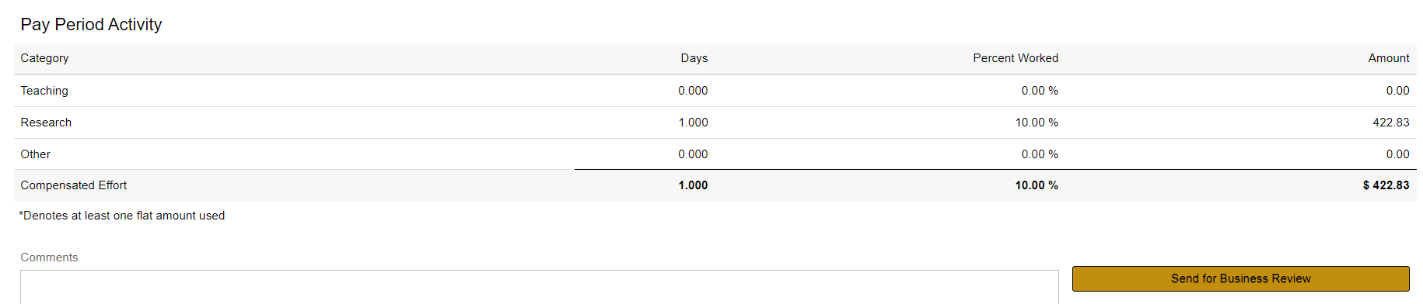  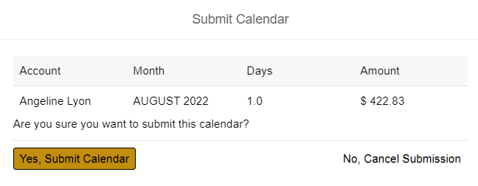

Pay Period Calculations
Calculation of pay is determined as follows:
In this example the employee works 6 days during the summer session in May, but have a FTE of 1.0  Full Time Annual Rate= Annual Salary/FTE  $99,600 /1.00 = $99,600  Daily Rate = Full Time Annual Rate x 2.778% /5 days x FTE  $99,600 x 0.02778/ 5 x 1.0 = $553.38 (Rounded to the nearest cent)  Full Time Period Rate = Full Time Annual Rate/9 Months  $99,600 / 9 = $11,066.67  Amount to be paid = Daily rate x number of days (in half day increments)  $553.38 x 6 = $3320.28 | 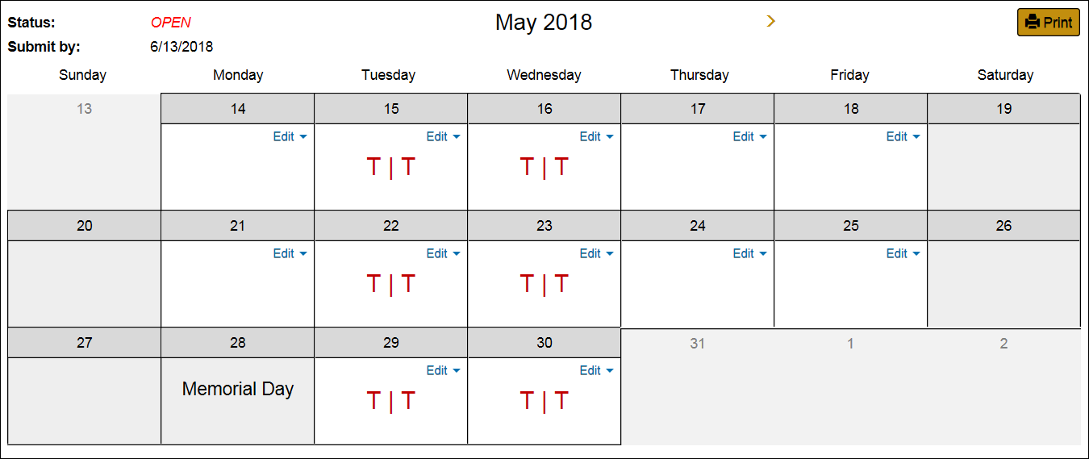  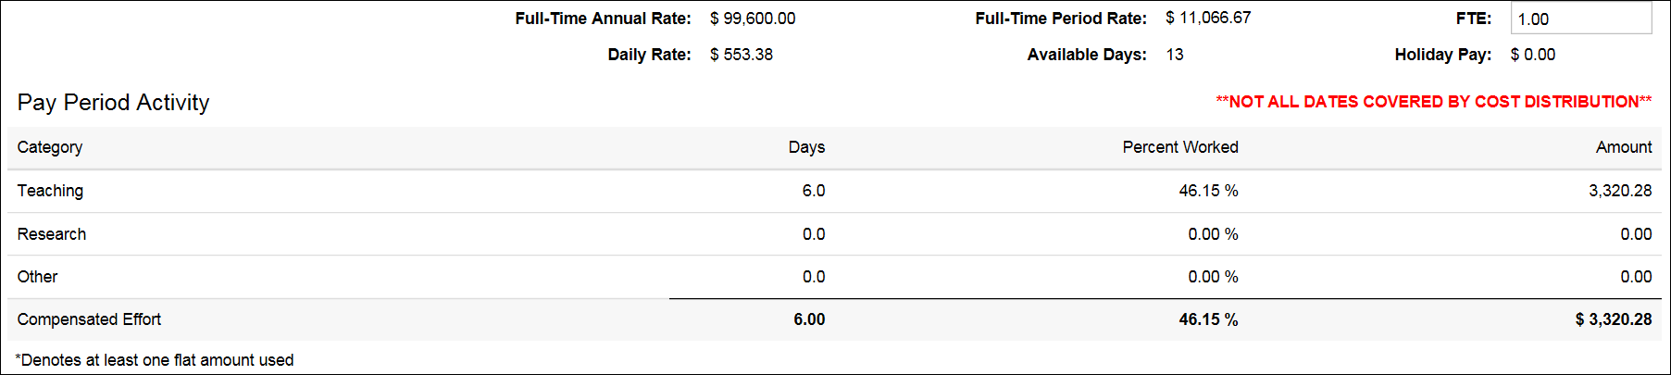
For example, this employee has an FTE of .50 and is scheduled to work 6 days during the summer session in May.  BEST PRACTICE: Any time the FTE is less than 1, a full day should be used in the calendar.  Full Time Annual Rate = Annual Salary/FTE  $51,801/0.5 = $103,602  Daily Rate = Full Time Annual Rate x 2.778% /5 Days x FTE  $103,602 x 0.02778/ 5 x 0.5 = $287.81 (Rounded to the nearest cent)  Full Time Period Rate = Full Time Annual Rate/9 Months  $103,602 / 9 = $11,511.33  Amount to be paid = Daily rate x number of days (in half day increments)  $287.81 x 6= $1,726.86 | 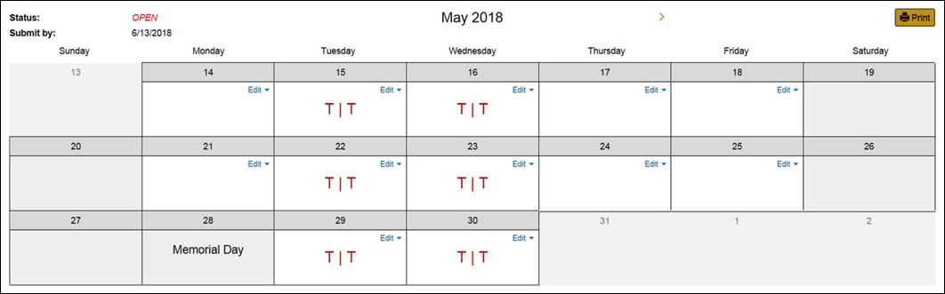  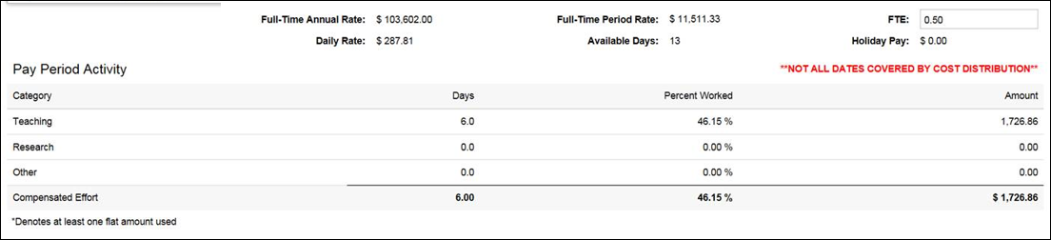

Subordinates
Faculty members can create calendars on behalf of their listed subordinates.
From the Summer Pay Dashboard, select the My Subordinates tab, locate the individual under the Summer column or  Click on the Search button to open the option. Search by either PERNR, Name or Career Account.  If the subordinates are listed under Summer, select the VIEW button | 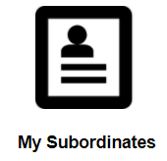
A summer pay calendar can now be created for the individual. | 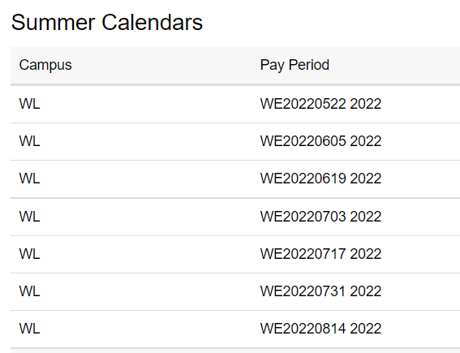
Select the desired calendar and create the schedule as mentioned in the previous steps.  The Subordinate templates allow you to utilize established templates to populate the calendars. | 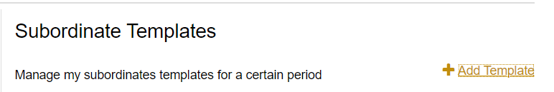

Multiple Appointments
For employees with multiple appointments (PERNRs), a calendar for each appointment should be submitted.
A list of appointments is displayed on the SEEMLESS Dashboard. | 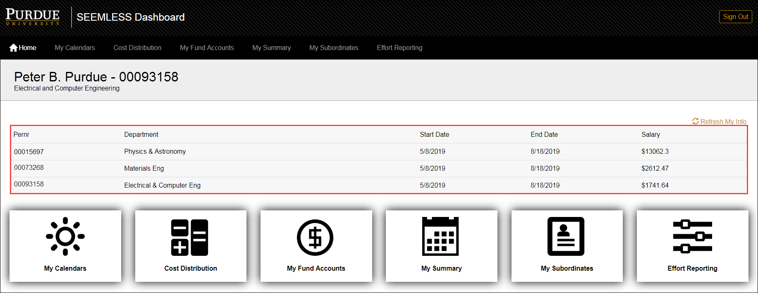
Click to select the desired PERNR and then proceed with completing the calendar. | 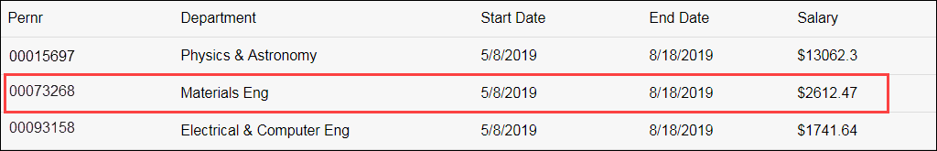

Submission
Click Send for Business Review to route to the business office for review/approval.  Confirm that you want to Yes, Submit Calendar or No, Cancel Submission | 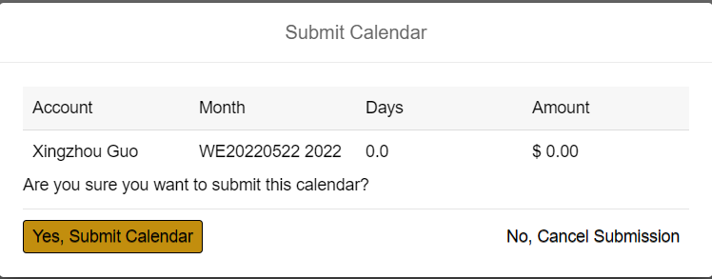
The business office will review the entries and make changes as needed. Once finalized, the calendar is submitted to Payroll for processing.

